**1.To find out the list of months from a particular year2.to get the day of a particular day\**

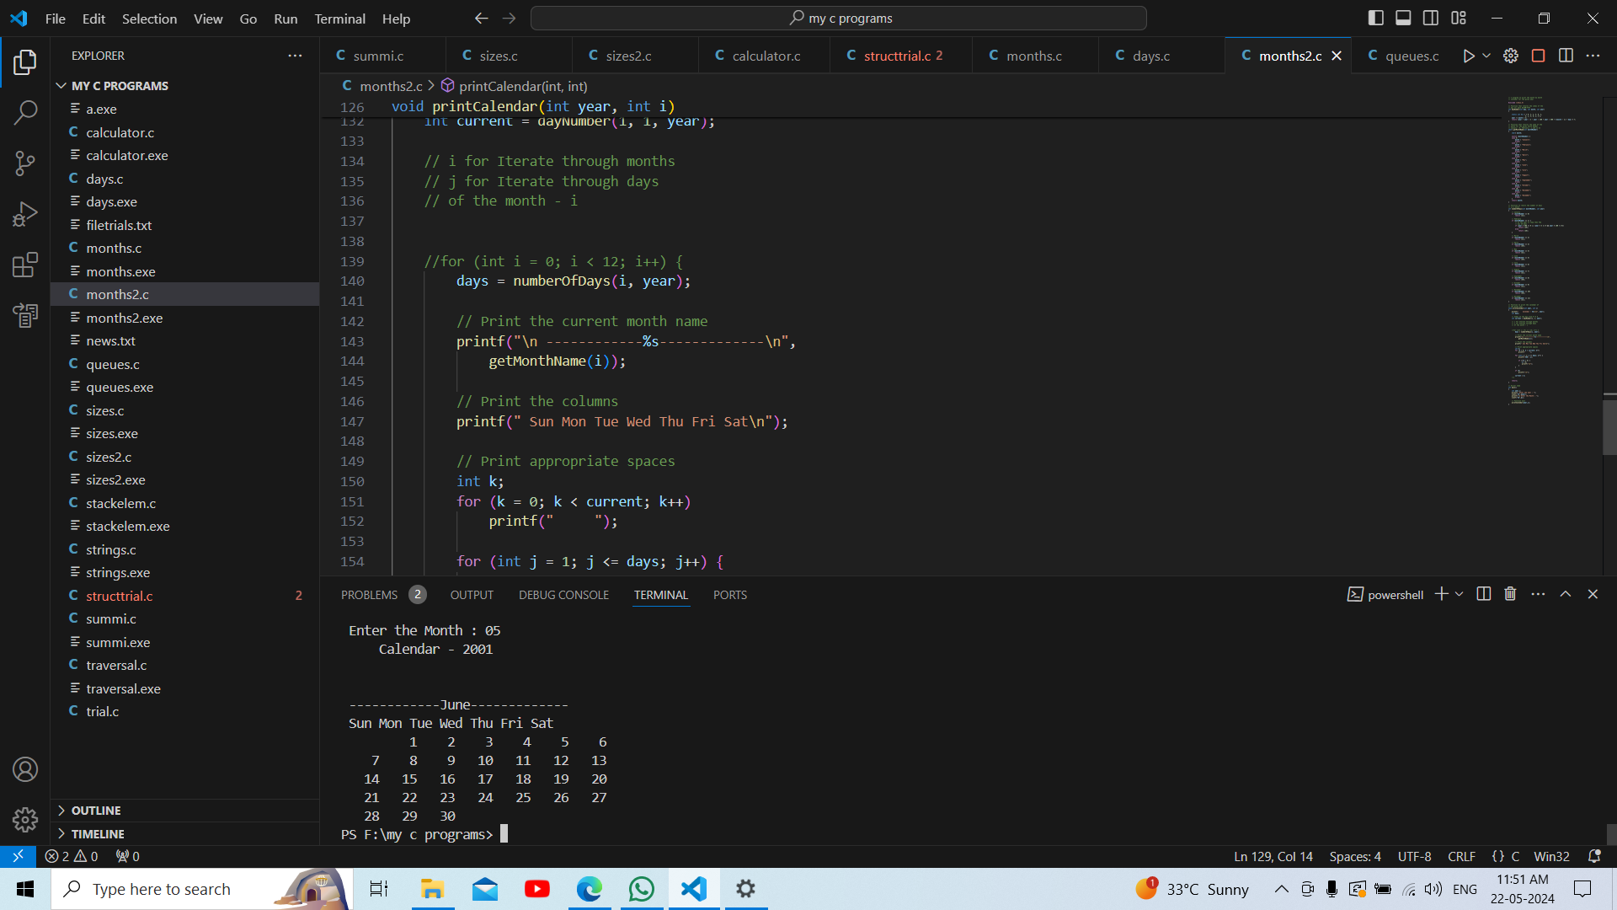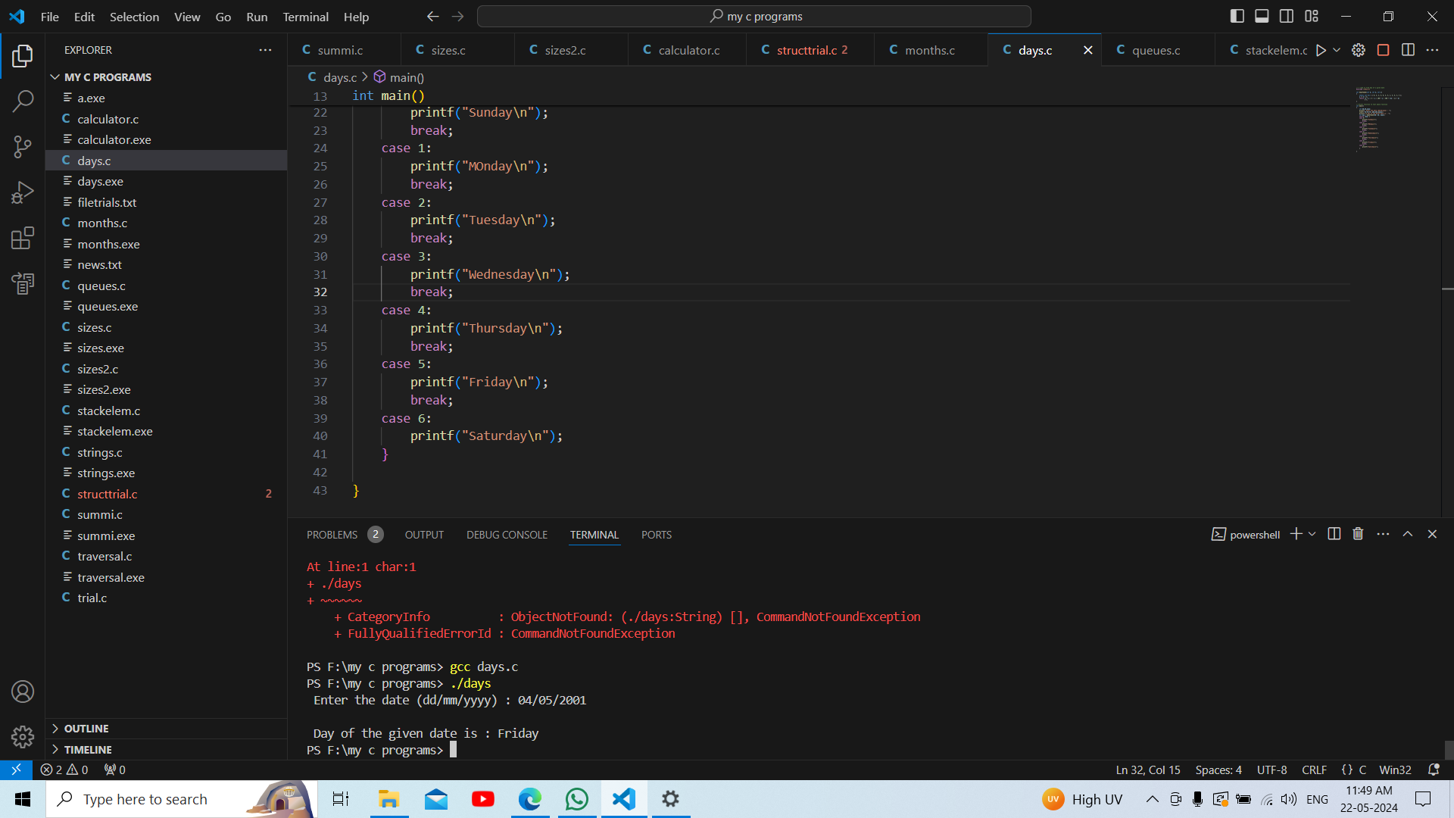

**3.to print the month calendar this id the calculator program this is representation of the elements in the stackthis is to print the sizes of the elememnts**

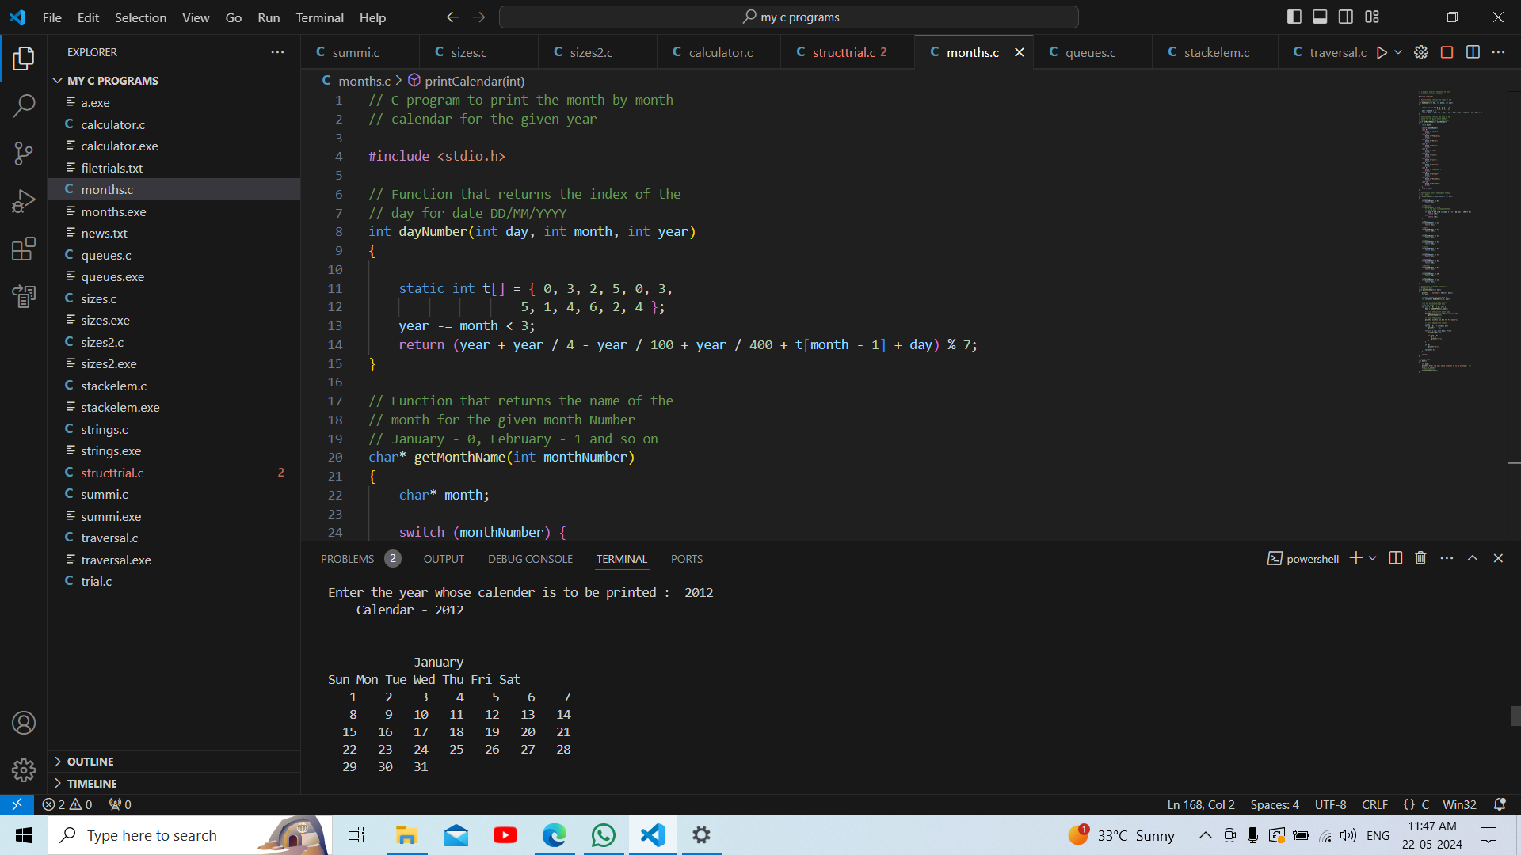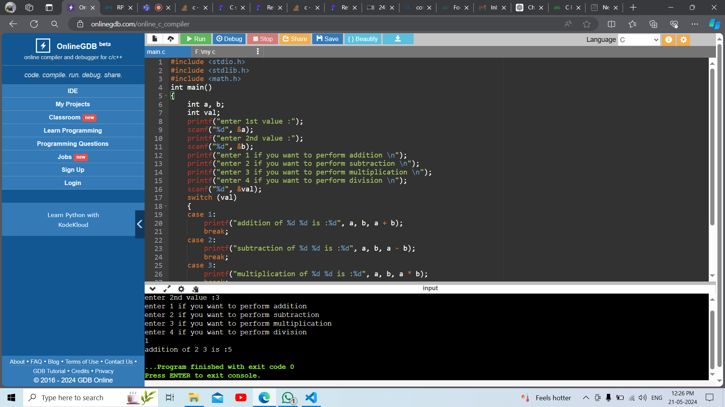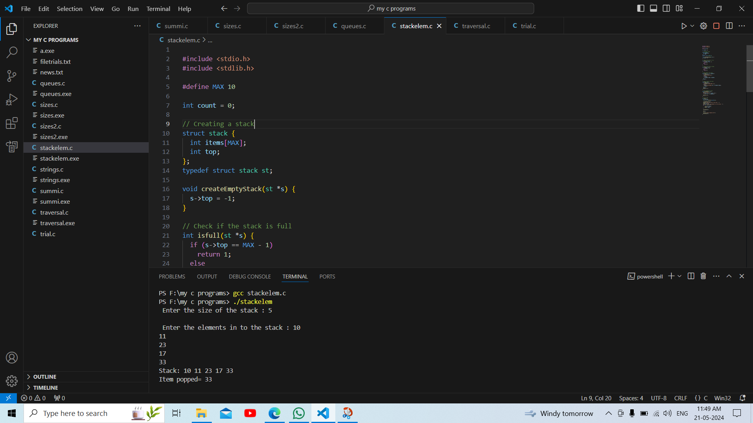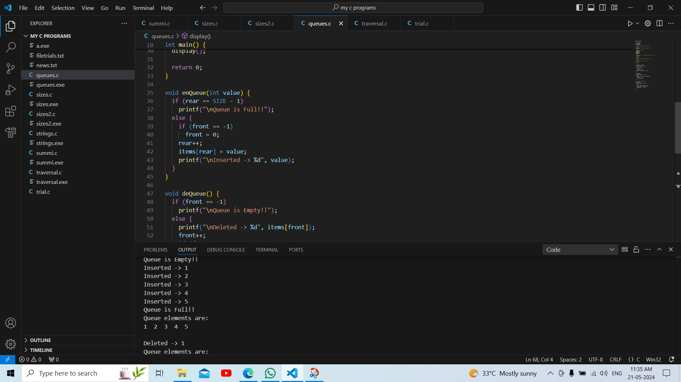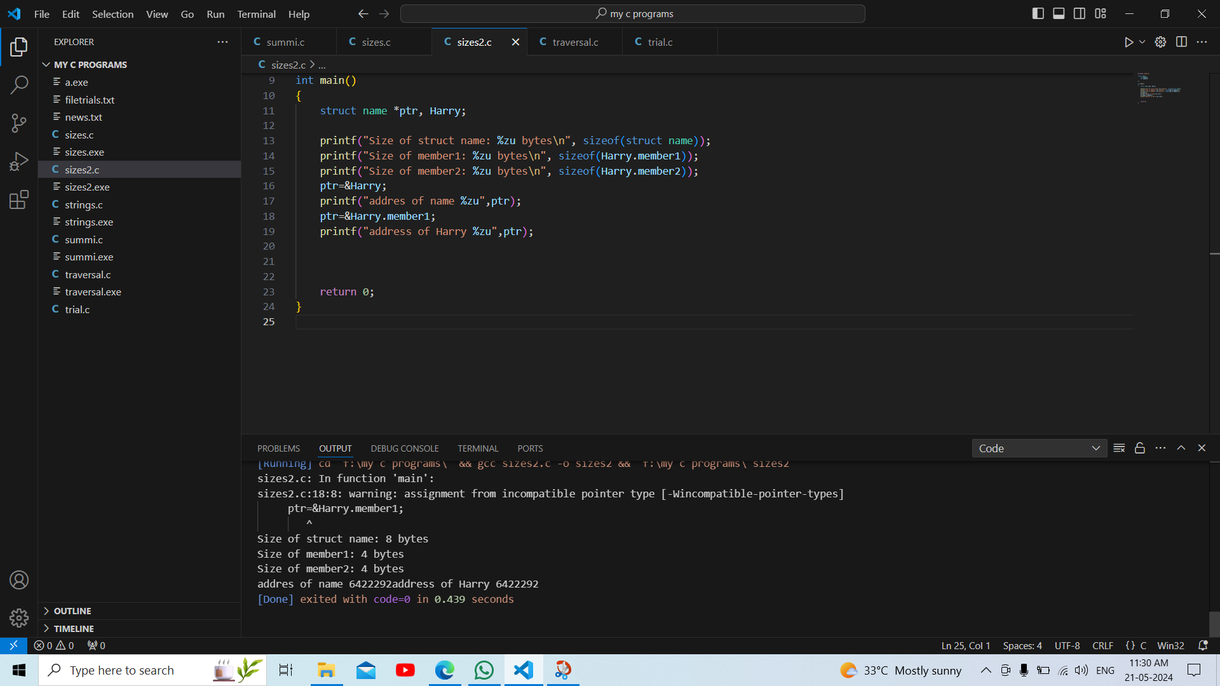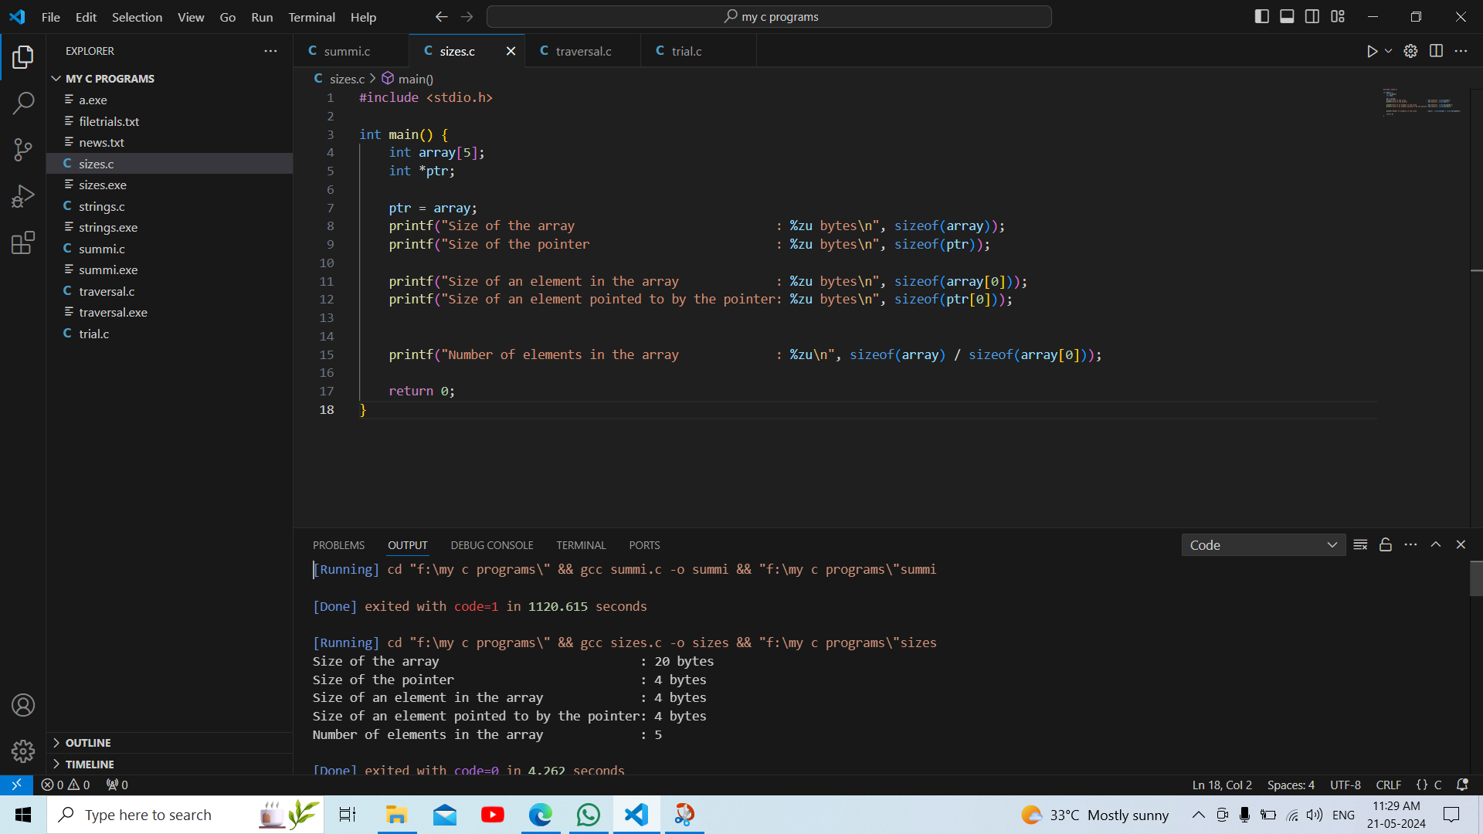

**this is the program for the traversal this program represernts the sum of all the en elememrntscalculation of prime numbersimplementing structure data structure here**

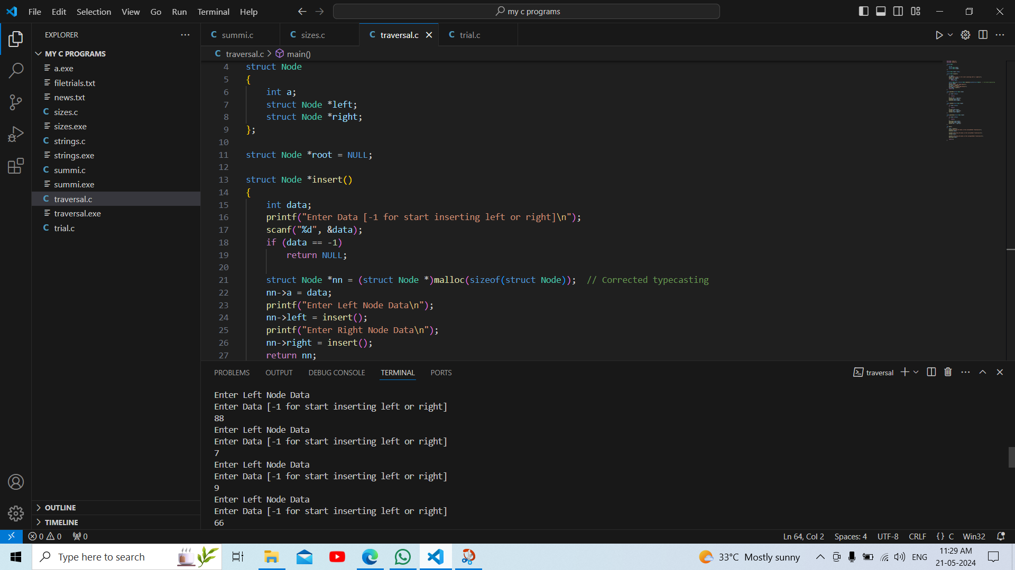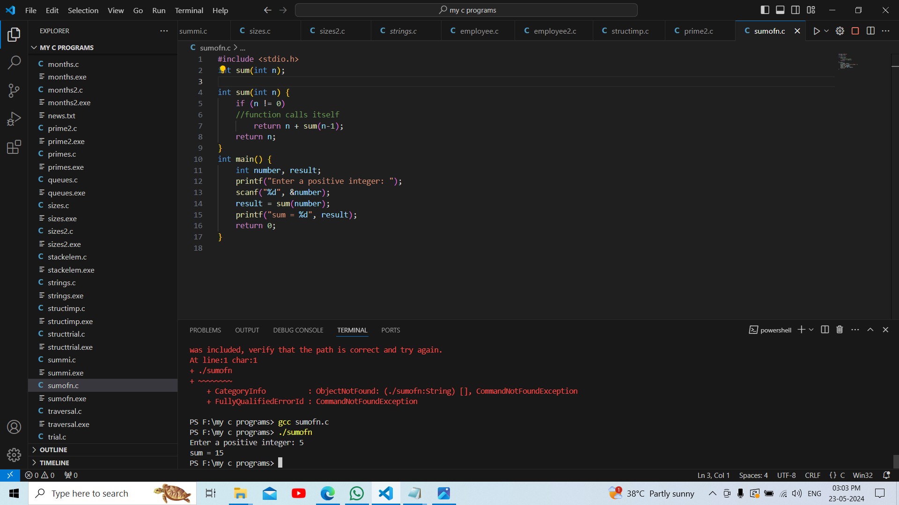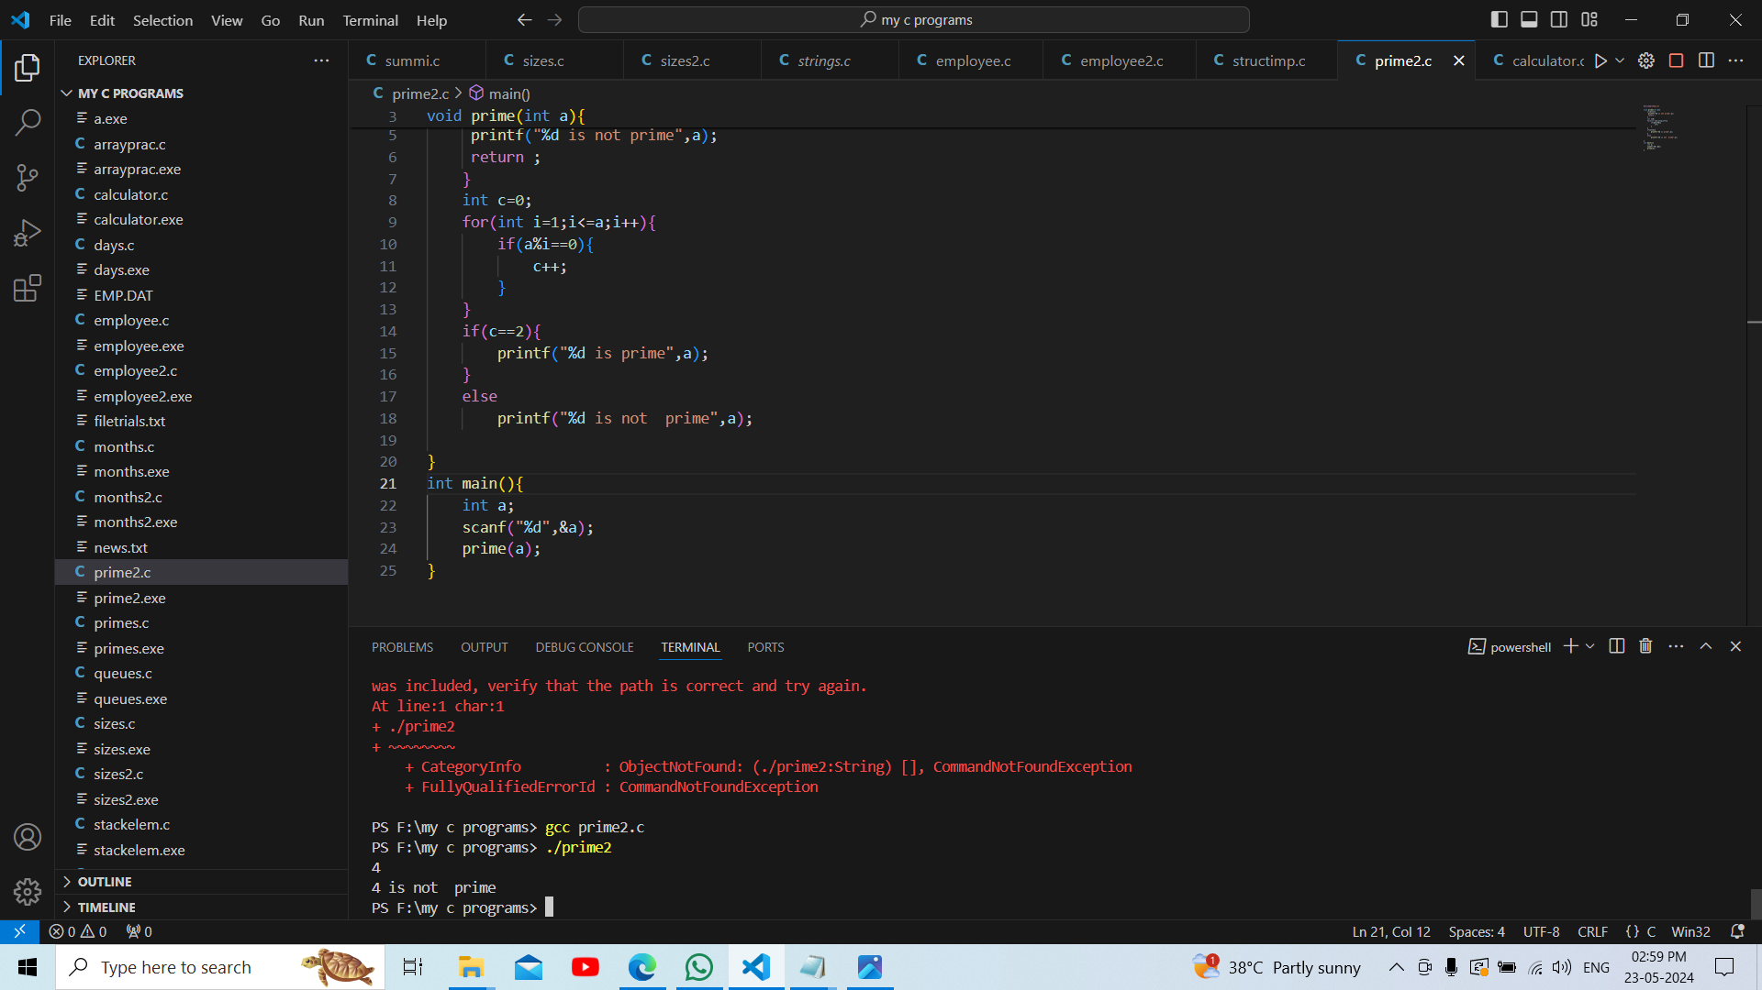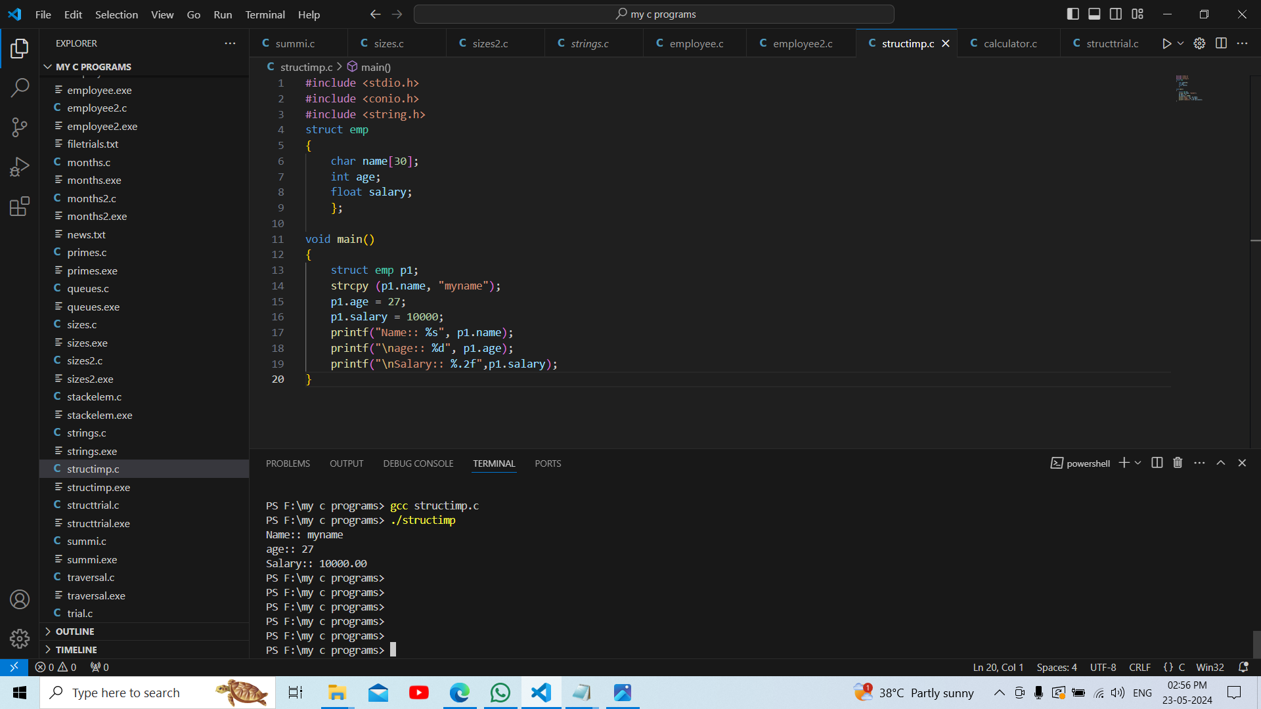

**employee management system approach 1employee management system approach 2identifying prime numbers from 1-100file handling basiccsstrings basics operations from the static user inputgathering students data throught arrays implementation**

